|  |
| --- |
| **Analysis By SQL** |

* **Overview page Report By (SQL)**

**1- Total Employees:**

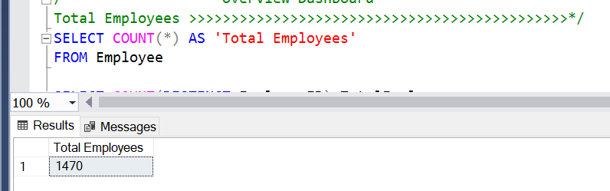

**2- Attrition count :**

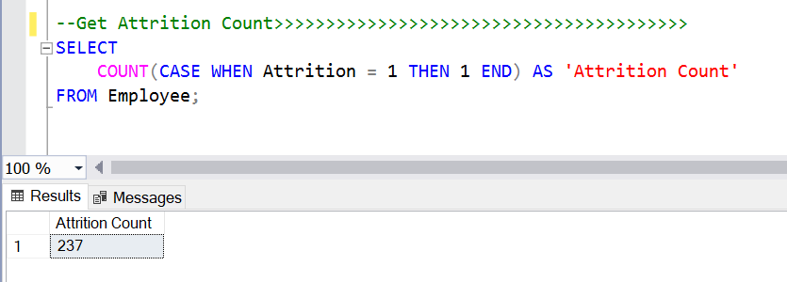

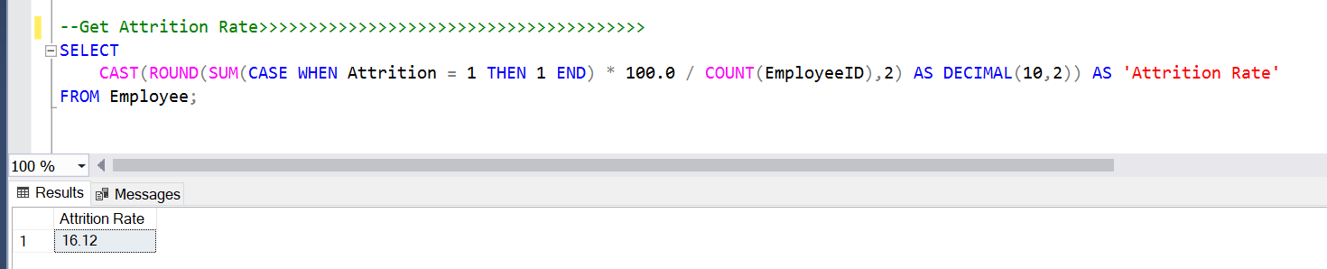**3- Attrition Rate:**

**4- Average Salary:**

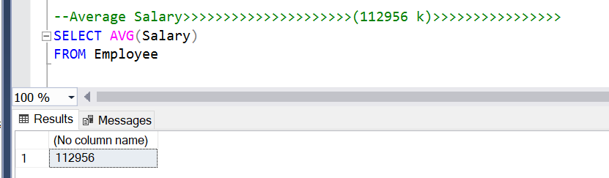

**5- Average Age**

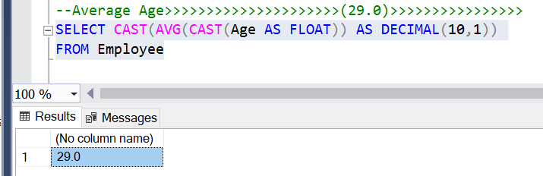

**6- Average Years at Company**

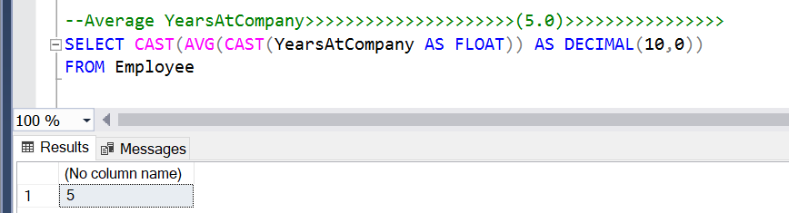

**7- OverTime**

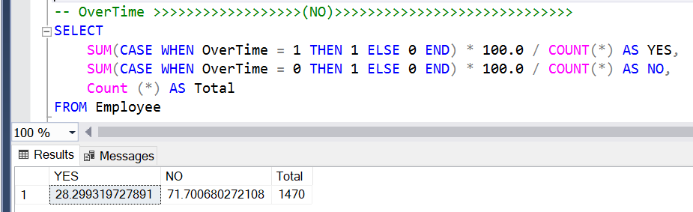

**8- Percentage of Gender Distribution**

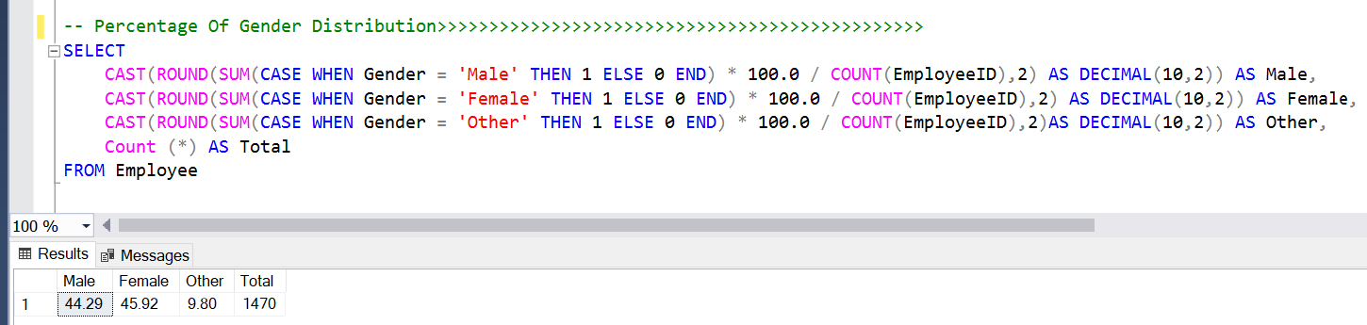

**9- Percentage of Age Range &Gender Distribution**

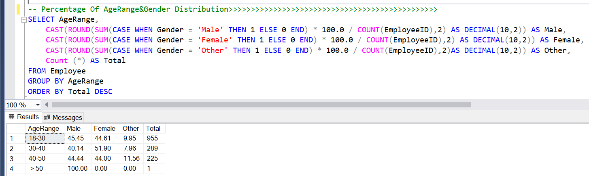

* **Employee page Report By (SQL)**

1. **Employee will be promoted:**

📌 **Key Promotion Criteria:**

* **Average Manager Rating** (Avg_ManagerRating) should be greater than 4.0.
* **Years Since Last Promotion** (YearsSinceLastPromotion) should be greater than 4 years.

**📊 Key Findings:**

* **Recruiters** have the highest average manager rating (4.48), making them the most likely candidates for promotion.
* **Senior Software Engineers** and **Data Scientists** follow closely behind with 4.33 and 4.30 ratings, respectively.
* **Machine Learning Engineers** have the lowest average manager rating (4.24), indicating they are least favored for promotion among the eligible roles.
* Most job roles have **5 years since their last promotion**, meaning they have been waiting for a promotion for a significant period.

✅**Potential Business Actions:**

The organization might consider focusing on promotions in job roles with the highest average ratings first.

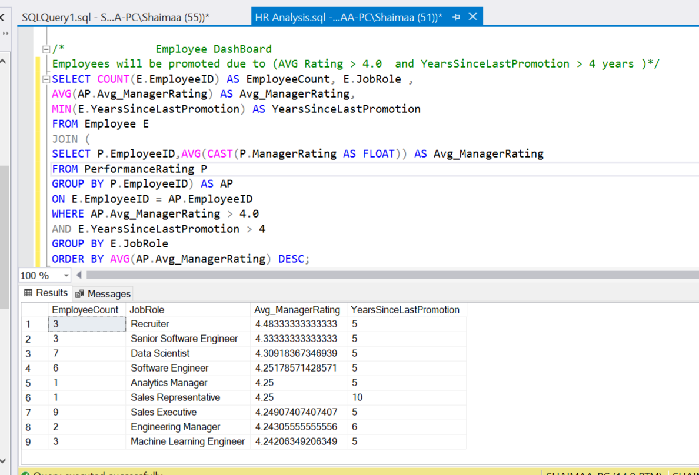

**2-Employees will be retrenched**

📌 **Key Retrenchment Criteria:**

1. Average Manager Rating (Avg_ManagerRating) is below 3.5
   * This indicates poor performance as per the manager’s evaluation.
2. Years in Most Recent Role (YearsInMostRecentRole) is more than 5 years
   * Suggests employees have been stagnant in their role for a long time without progression.

**📊 Key Findings:**

1-HR Managers (Avg Rating: 2.6) are at the highest risk due to the lowest average manager rating.

2-Recruiters and Managers have been flagged despite their relatively higher ratings (around 3.27 - 3.37).

✅**Potential Business Actions:**

1- Identify performance gaps:

* Conduct deeper performance evaluations to confirm if retrenchment is the best course of action.

2-Training & Development:

* Consider reskilling or upskilling employees instead of immediate retrenchment.

3- Career Progression Review:

* If employees have been in the same role for too long, career mobility initiatives may help.

4-HR & Sales Intervention:

* Investigate why HR and Sales roles have the lowest ratings and stagnation issues.

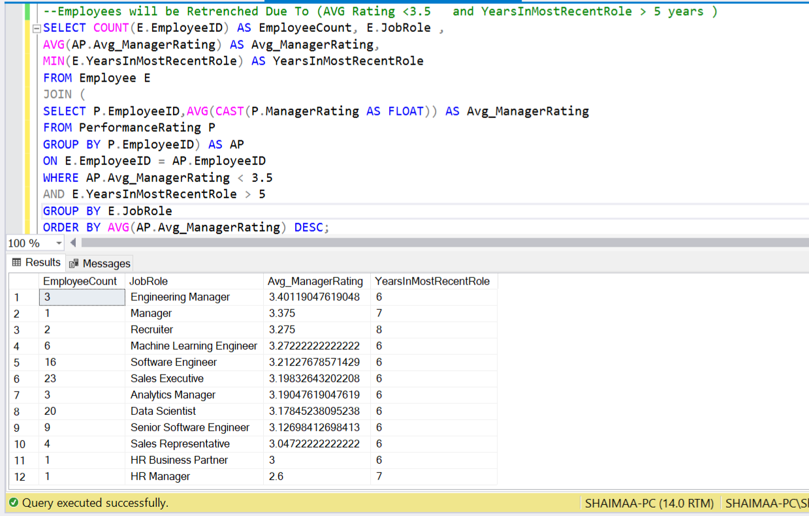

`

**3-Employee who will be retired each year based on their current age and assuming a retirement age of 65 years.**

📌 **Criteria for Employee Retirement:**

Retirement Age = 65 Years

The assumption is that all employees retire at the age of 65.

**📊 Key Findings:**

1-The first retirement happens in 2037, meaning the oldest employee is currently 49 years old (2023 - (65 - 49)).

2-The number of retirees increases over time, with peaks in certain years:

* 2045: 32 employees
* 2052: 32 employees
* 2053: 30 employees

3-The fluctuation in the number of retirees indicates variations in hiring trends over the years.

✅**Potential Business Actions:**

**Hiring Strategy Adjustments:**

* If retirements peak in certain years (e.g., **2045, 2052**), hiring plans should **ensure skill continuity**.
* Helps in **balancing workforce experience levels**.

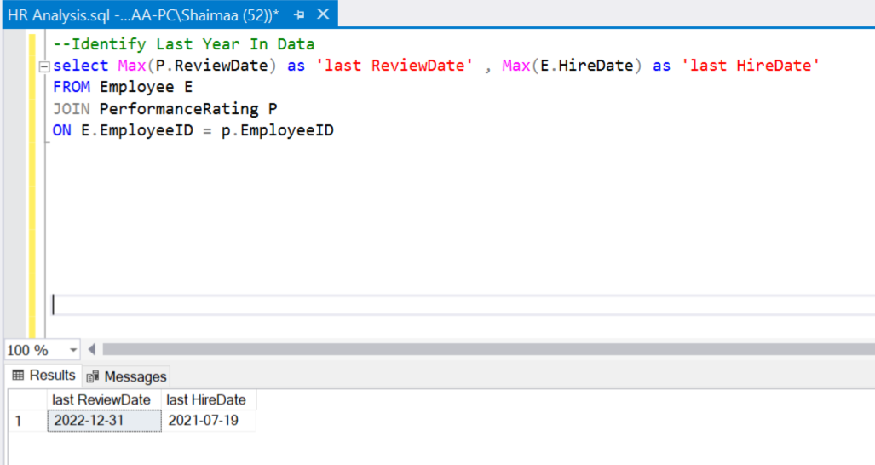

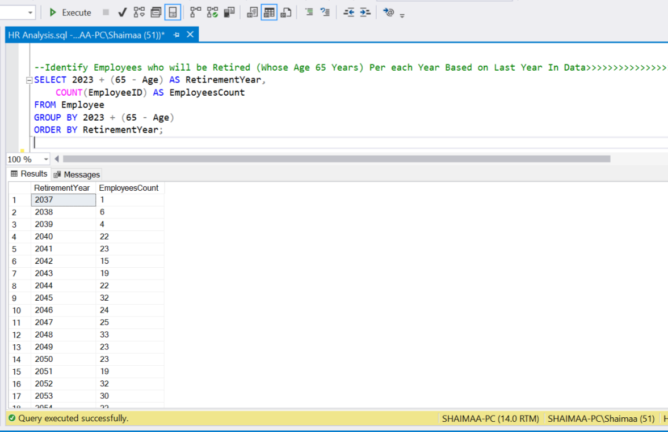

**2-**

**4- Top 5 Employees Due to Performance**

**📊 Key Findings:**

The top 5 employees all have a **perfect manager rating of 5.0**.

✅**Potential Business Actions:**

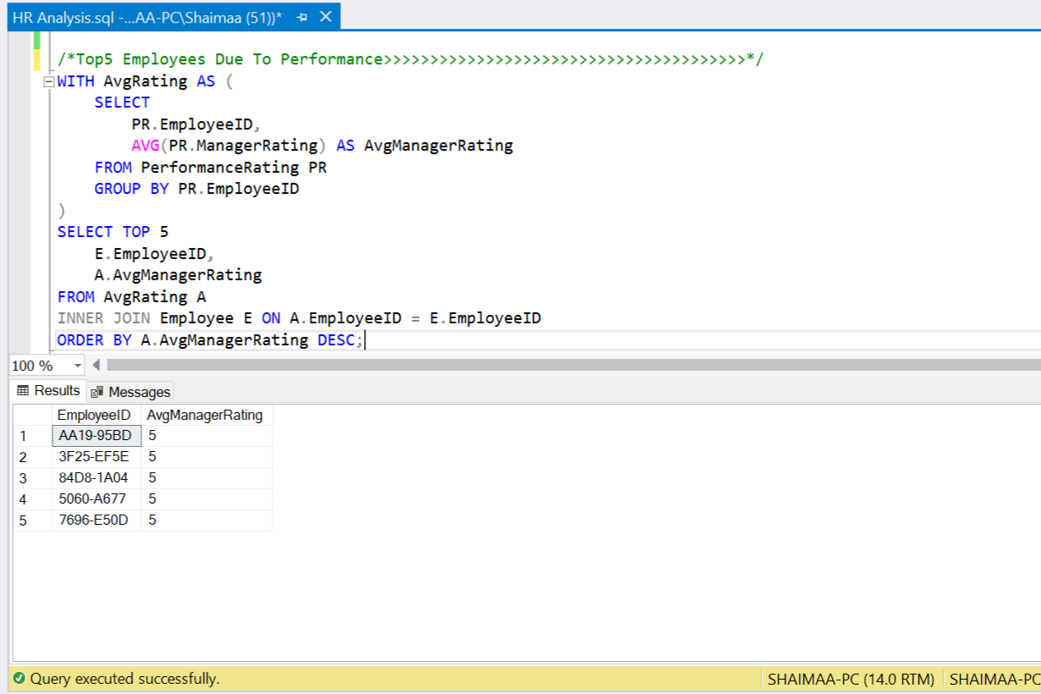The top 5 employees are a **valuable asset** to the company. Taking proactive steps to **recognize, reward, and retain** them ensures continued high performance and strengthens overall workforce morale.

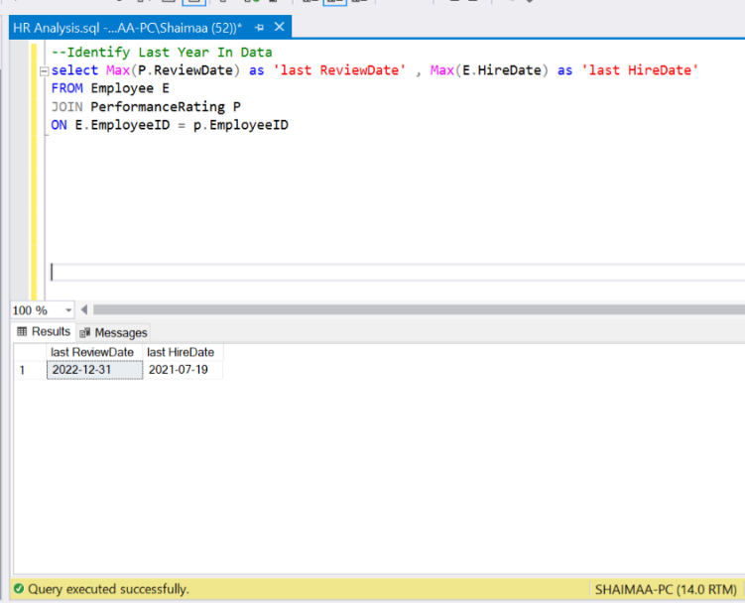

* **Salary page Report By (SQL)**

**1- MAX ,MIN and AVG Salary**

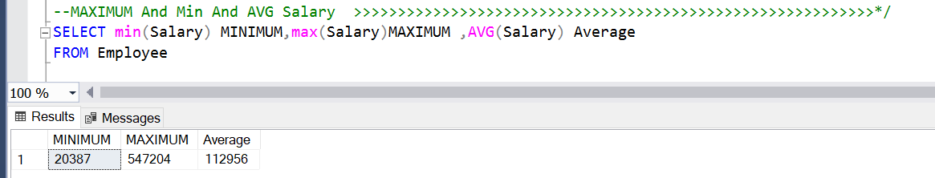

1. **Lowest Salary Per Age Range, Gender**

**📊 Key Findings:**

**Lowest Salary Group:**

* **Males (18-30 years)** have the lowest **average salary** at **73,242**.
* This suggests that young male employees are the lowest-paid group.

✅**Potential Business Actions:**

Support Young Employees (18-30) with Career Growth:

* Since young employees earn the least, offering mentorship programs, upskilling, and performance-based salary growth can improve retention and motivation.

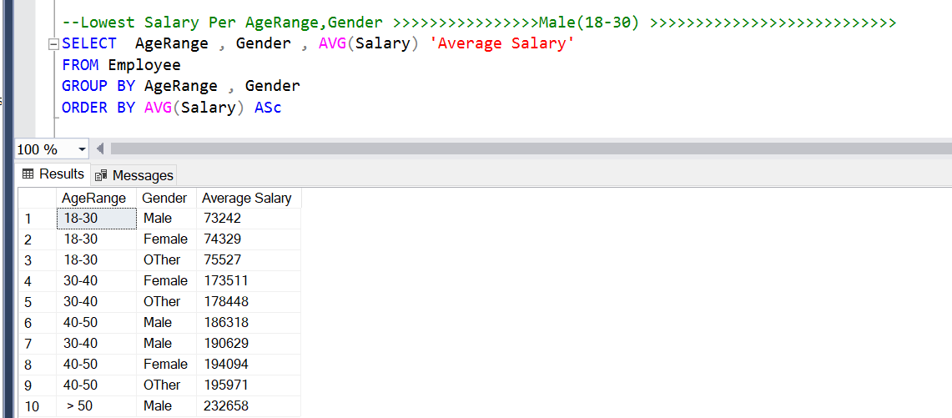

1. **Highest Salary Per Age Range, Gender**

**📊 Key Findings:**

Highest Salary Group:

* Males aged > 50 years earn the highest average salary at 232,658.
* This aligns with experience and seniority-based salary increments.

✅**Potential Business Actions:**

Retirement & Succession Planning

* The highest-paid employees (>50 years) may retire soon.
* Organizations should prepare mid-career employees to take on leadership roles.

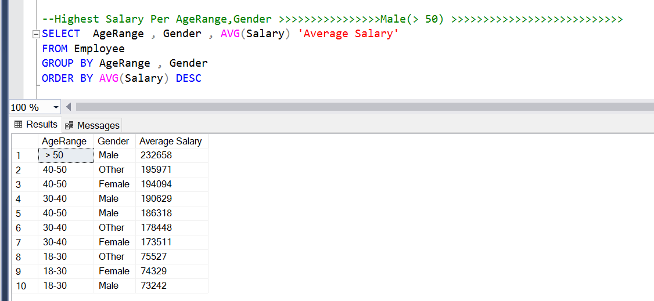

1. **Highest Salary Per Department**

**📊 Key Findings:**

Highest-Paid Department:

* Human Resources (HR) employees have the highest average salary (119,698).
* This is slightly higher than Sales (119,566) and significantly higher than Technology (109,436).
* HR’s high salary could be due to strategic roles, policy-making, and leadership involvement.

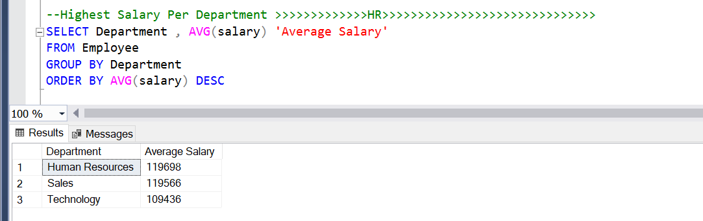

1. **Highest Salary Per Job Role**

**📊 Key Findings:**

1️-HR Manager Has the Highest Average Salary:

2- Managers & Business Partners Earn High Salaries:

3️-Technical & Engineering Roles Vary in Salary:

* Engineering Manager (286,258) earns a strong salary, but lower than business-focused roles.
* Machine Learning Engineers (130,164) and Senior Software Engineers (126,161) earn lower than expected, despite the high demand for AI and tech skills.

4️-Sales & HR Executives Earn Mid-Level Salaries:

* Sales Executive (117,195) and HR Executive (94,362) earn moderate salaries, indicating they are likely mid-level roles.

5️-Data Science & Software Engineering Roles Are Lower-Paid:

* Data Scientists (56,079) and Software Engineers (51,967) earn significantly less than managers and business-focused roles.

6️-Recruiters Have the Lowest Salary:

✅**Potential Business Actions:**

1-Review HR Manager Salary Structure:

* Is the HR Manager salary (449,330) justified?
* Compare with industry benchmarks to ensure competitiveness without overcompensation.

2-Re-Evaluate Recruiter Salary:

* Recruiters (37,647) have the lowest salary, which affect hiring efficiency as turnover is high.(Clarified in attrition per Job role)

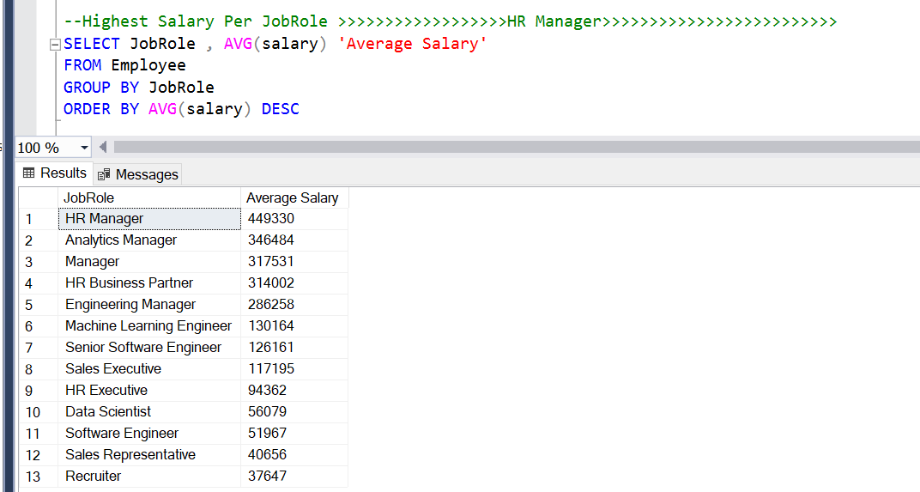

1. **Salary Per Over Time**

**📊 Key Findings:**

**1-Employees Who Work Overtime Earn Slightly Higher Salaries**

* With Overtime: $114,953 (Average Salary)
* Without Overtime: $112,168 (Average Salary)
* Employees who work overtime earn about 2.5% more than those who don’t.
* The salary difference is small, meaning overtime is not significantly rewarded.

**2️-Higher Attrition Among Employees Who Work Overtime**

* 30.53% of employees who work overtime leave the company (attrition = YES).
* Only 10.43% of employees without overtime leave.
* This indicates that overtime is a key factor contributing to employee attrition.

**3️-Most Employees Do Not Work Overtime**

* 416 employees work overtime, while 1,054 employees do not.
* This suggests that overtime is not a common practice in the company.

✅**Potential Business Actions:**

1-Investigate Workload & Burnout Issues

* High attrition (30.53%) among overtime workers suggests stress, burnout, or dissatisfaction.
* Conduct employee surveys to assess overtime policies and work-life balance.

2-Consider Adjusting Overtime Compensation

* The salary difference (2.5%) is small, meaning overtime may not be financially rewarding enough.
* A higher overtime pay rate or additional incentives could reduce dissatisfaction and turnover.

3- Promote Work-Life Balance

* Employees without overtime have a much lower attrition rate (10.43%), meaning less overtime could improve retention.
* Encourage task automation, flexible schedules, or workload redistribution to minimize excessive overtime.

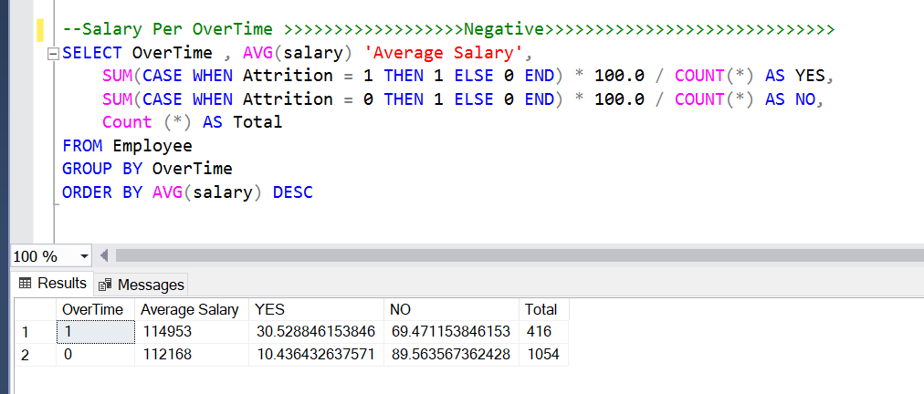

* **Attrition page Report By (SQL)**

**1- Attrition count:**



**2- Attrition Rate**



**3- Attrition per Marital Status**

**📊 Key Findings:**

Single employees have the highest attrition rate – 23.31% of single employees left the company, which is higher than the attrition rates for married and divorced employees.

✅ **Possible reasons:** Single employees may have fewer personal responsibilities tying them to the company, making them more likely to leave for better opportunities. Married and divorced employees might have greater financial and family commitments, leading to lower attrition.

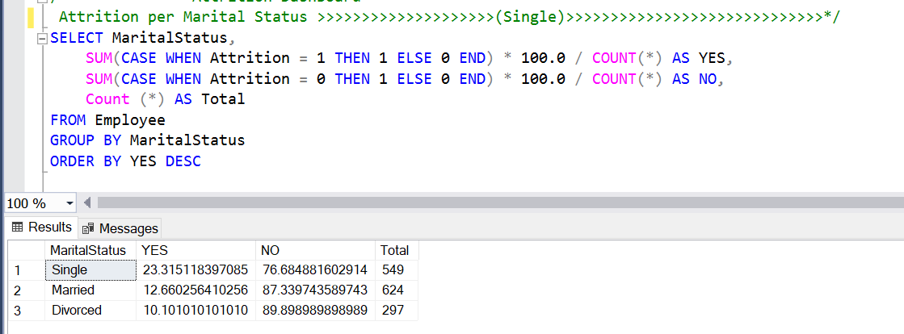

**4- Attrition Per Age Range, Gender**

**📊 Key Findings:**

Highest Attrition Rate (Young Males & Females)

✅ **Possible reasons:**

* **Young Employees (18-30) Leave More**

May switch jobs for better opportunities.

Less job stability or satisfaction.

Exploring career paths.

* **Attrition Declines with Age**

Older employees tend to have more stable careers.

Higher responsibilities and benefits lead to lower turnover.

* **Gender Differences in Attrition**

Males may have higher mobility or external job offers.

Female attrition could be influenced by work-life balance considerations.

The "Other" category also sees high early-career attrition, possibly due to workplace inclusivity factors.

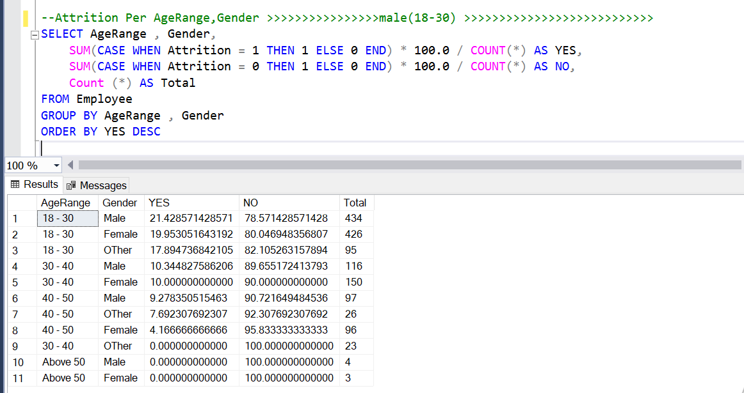

**5- Attrition Per Gender**

**📊 Key Findings:**

Males Have the Highest Attrition Rate

* Male Attrition Rate: 17.51% (Highest)
* This suggests that male employees leave the company at a higher rate than females and other genders.

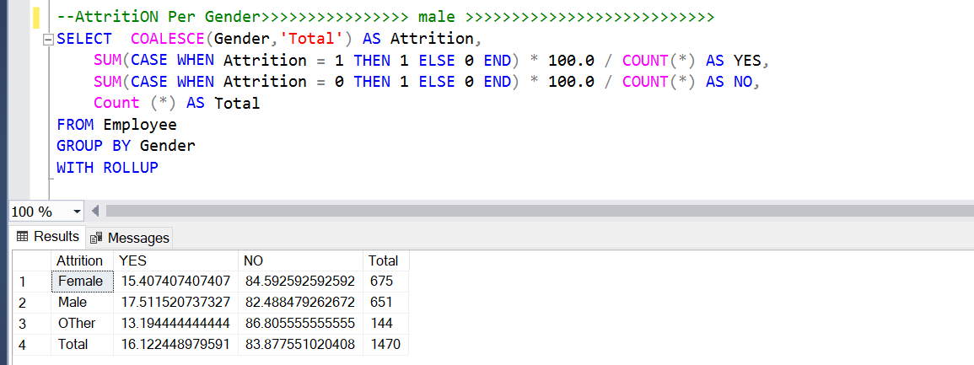

**6-Attrition per salary**

📊 Key findings:

* Higher Salary = Higher Retention

Employees with lower salaries tend to leave more frequently, possibly due to better job opportunities, dissatisfaction, or cost-of-living concerns.

* Attrition is Less Predictable at Mid-Level Salaries

Some employees in the mid-salary range ($100K - $300K) leave at fluctuating rates, suggesting job role-related or career growth factors at play.

* Executives & Highly Paid Employees are More Stable

After $350K, very few employees leave, likely due to strong retention incentives like bonuses, stock options, and leadership roles.

✅**Potential Business Actions:**

* **Improve Compensation for Lower-Paid Employees:**

Consider salary adjustments, performance-based raises, or additional financial benefits for employees earning below 50K.

* **Address Non-Financial Retention Factors:**

Since attrition exists even in higher salary groups, factors like career growth, job satisfaction, and work-life balance should also be considered.

* **Targeted Retention Strategies for Low-Salary Employees:**

Introduce skill development programs, career progression plans, and mentorship opportunities to increase job satisfaction.

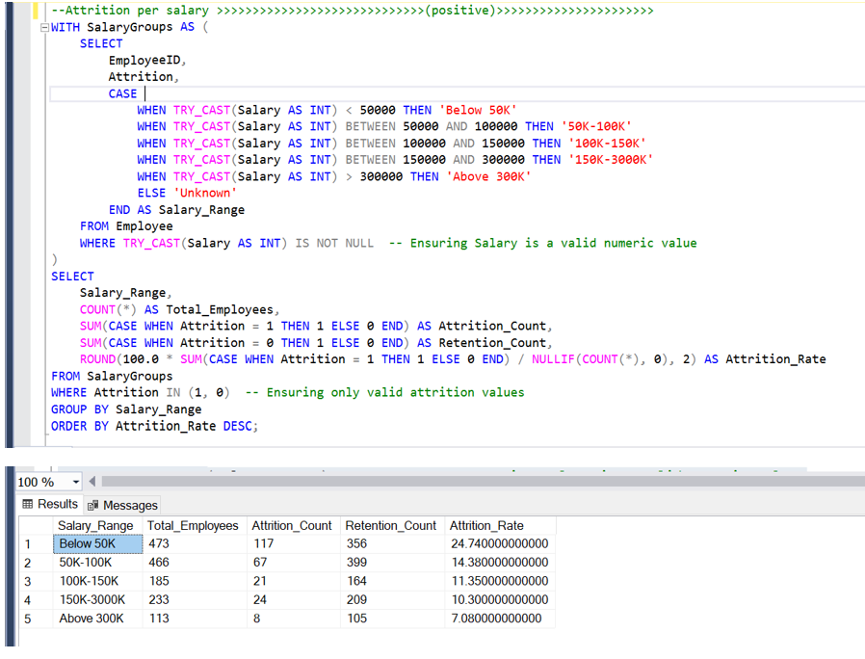

1. **Attrition Per Department:**

**📊 Key findings:**

* **Highest Attrition in Sales**
  + Sales department has the highest attrition rate (20.58%), meaning more than 1 in 5 employees leave.
  + Sales roles often have high-pressure environments, performance-based compensation, and frequent job-hopping, which could explain the high turnover.
* **Moderate Attrition in Human Resources (HR)**
  + HR department has an attrition rate of 19.05%, slightly lower than Sales.
  + This could be due to job dissatisfaction, career growth limitations, or workload-related stress.
* **Lowest Attrition in Technology**
  + Technology department has the lowest attrition rate (13.85%), indicating better retention.
  + Higher salaries, skill-based career growth, and flexibility (such as remote work) could contribute to employee stability in this field.

✅**Potential Business Actions:**

* For Sales

-Improve commission structures, provide better work-life balance, and offer growth opportunities to retain talent.

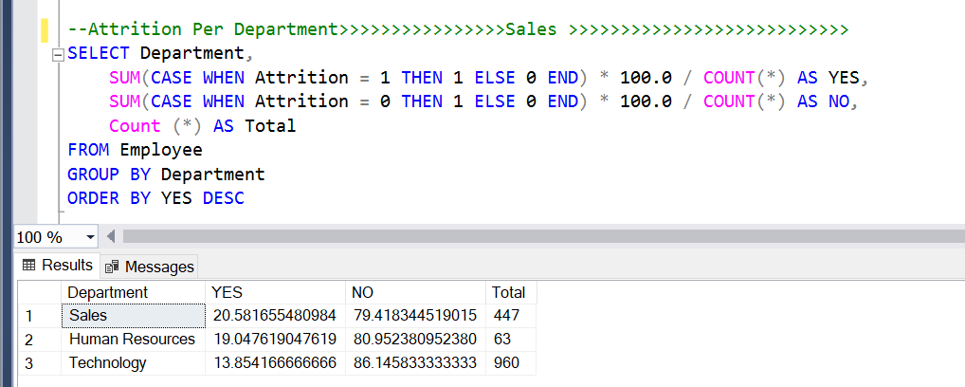

**8- Attrition per Department: YES**

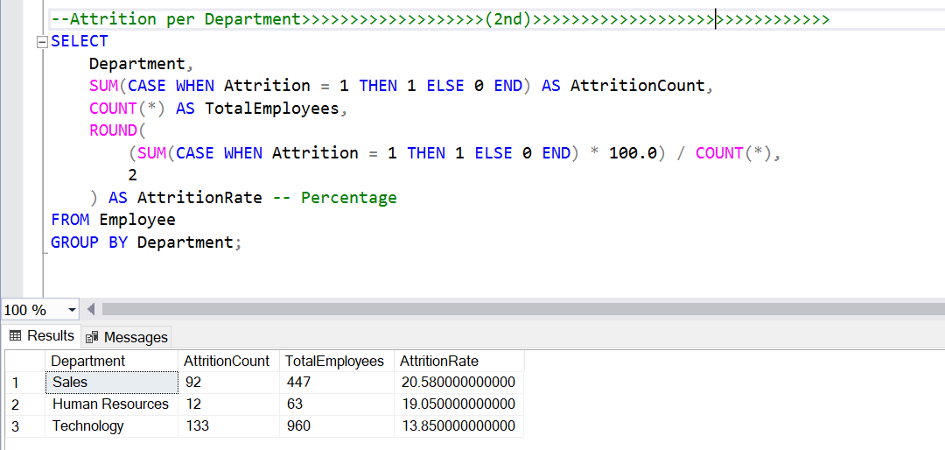

**9-Attrition Per JobRole**

**📊 Key findings:**

1. **High Attrition in Recruiters (37.5%)**
   * Recruiters experience the highest turnover, possibly due to job stress, high performance targets, or limited career growth.
   * Competitive job market could be a reason, with recruiters moving to better-paying companies.
2. Data Scientists Have a High Attrition Rate (23.75%)
   * Data Scientists have a relatively high turnover, likely due to better opportunities in the industry, demand for AI/ML skills, or lack of challenging work.
3. Sales Executives Have Moderate Attrition (17.43%)
   * As expected, sales roles face moderate turnover, possibly driven by commission-based salaries, work pressure, and high expectations.
   * Improving incentives and work-life balance may reduce attrition.
4. Software Engineers (15.98%) and HR Executives (10.71%) Also Have Noticeable Attrition
   * Tech industry sees some job switching, but compared to other roles, retention is relatively stable.
   * HR Executives may leave due to burnout or limited career advancement.
5. Lowest Attrition in Leadership Roles (HR Managers, Business Partners, Engineering Managers, Managers)
   * Leadership positions (0-5% attrition) have the most stable retention, likely due to job security, higher compensation, and long-term commitment.

✅**Potential Business Actions:**

📌 For High Attrition Roles (Recruiters, Data Scientists, Sales Executives)

* Improve compensation, career growth opportunities, and work-life balance.
* Offer mentorship programs and retention bonuses.

📌 For Tech Roles (Software Engineers, ML Engineers)

* Focus on skill development, innovation-driven projects, and flexible work options to improve retention.

📌 For Low Attrition Leadership Roles

* Continue leadership development programs to maintain stability.

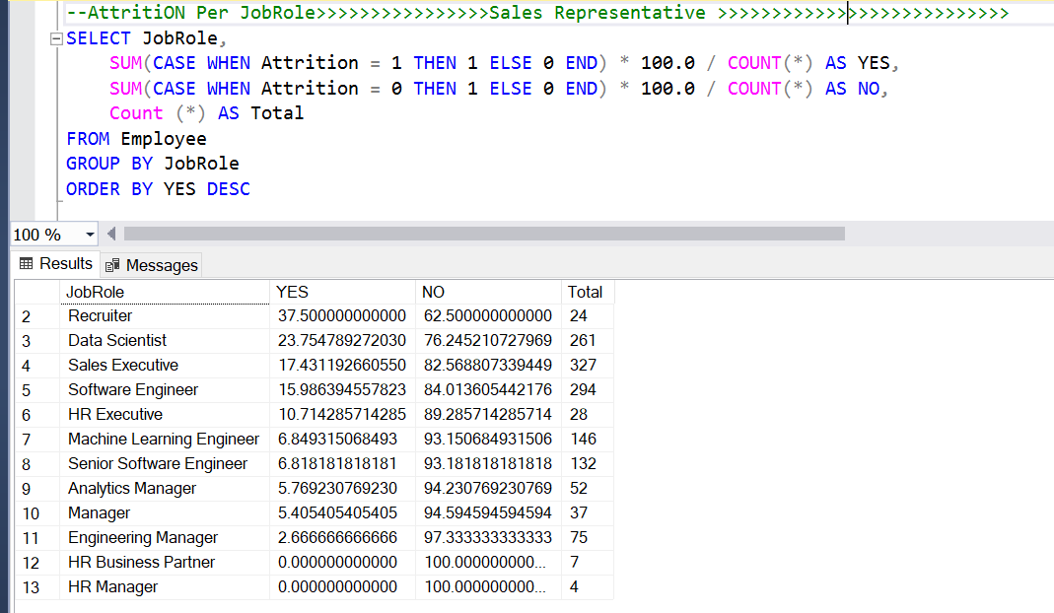

**10-Attrition per Years Since Last Promotion**

**📊 Key findings:**

1. **Higher Attrition in Employees Who Haven’t Been Promoted Recently (0-3 years)**
   * Employees with 0 years since last promotion have the highest attrition rate (37.87%), indicating that new hires or recently promoted employees leave frequently.
   * This could be due to unmet expectations, dissatisfaction with the new role, or external opportunities.
2. Attrition Declines as Time Since Last Promotion Increases (3-7 years)
   * Between 3-7 years, attrition rates stabilize at lower levels (~4-9%), suggesting that employees who stay for a few years tend to remain longer.
3. Lowest Attrition in Employees Who Haven’t Been Promoted for 8-10 Years
   * Employees with 8-10 years since last promotion have low attrition (~0-4%), indicating that long-tenured employees tend to stay despite lack of promotions.
   * These employees may have developed loyalty, job security, or are nearing retirement.

✅**Potential Business Actions:**

📌 For High Attrition Employees (0-3 Years Since Promotion):

* Improve onboarding and mentorship programs to increase retention.
* Offer clear career development paths to motivate new hires.
* Conduct stay interviews to understand why they are leaving.

📌 For Employees with 3-7 Years Since Last Promotion:

* Provide skill development and upskilling opportunities to keep them engaged.
* Recognize and reward loyalty through bonuses or benefits.

📌 For Long-Tenured Employees (8-10 Years):

* Explore leadership roles or lateral career moves to retain valuable expertise.
* Consider retirement planning benefits for those nearing the end of their careers.

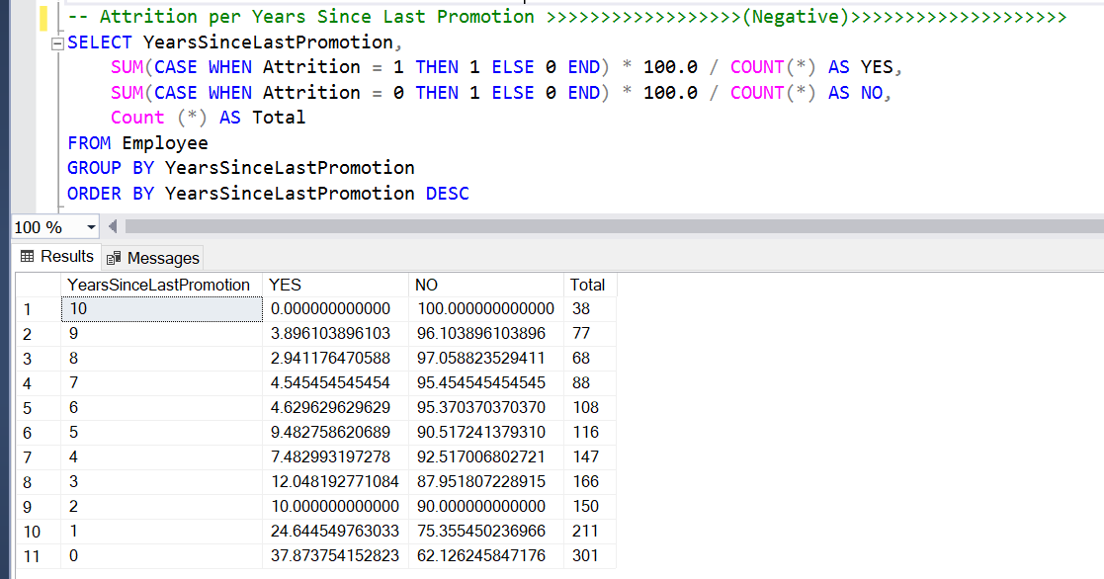

**11- Attrition per OverTime**

**📊 Key Findings:**

1. **Employees Who Work Overtime Have a Much Higher Attrition Rate**
   * Employees who do NOT work overtime (OverTime = 0) have an attrition rate of 10.44%.
   * Employees who work overtime (OverTime = 1) have an attrition rate of 30.53%—almost 3 times higher than those who don’t.
2. Overtime Employees Represent a Smaller Portion of the Workforce
   * 416 employees work overtime, compared to 1,054 employees who do not.
   * Despite this, overtime workers have a disproportionately high attrition rate.

✅ **Actionable Recommendations:**

**📌 Monitor and Reduce Excessive Overtime**

* High attrition suggests burnout and dissatisfaction among employees working overtime.
* Implement work-life balance policies, including caps on overtime hours.

📌 Offer Incentives & Support for Overtime Workers

* Provide higher compensation, extra leave days, or wellness programs for employees working overtime.
* Ensure overtime is distributed fairly to prevent employee exhaustion.

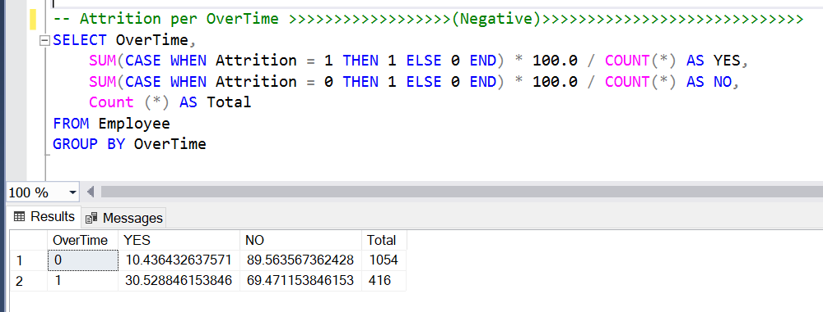

**12- OverTime Per Department**

📊 Key Findings:

**Overtime is Fairly Even Across Departments**

* + Sales: 28.86% of employees work overtime.
  + Human Resources: 26.98% of employees work overtime.
  + Technology: 28.13% of employees work overtime.

All departments have overtime percentages between 26% and 29%, indicating no extreme variations in workload distribution.

**✅ Actionable Recommendations:**

📌 Assess Employee Burnout Across Departments

* Since overtime rates are fairly consistent across departments, attrition trends should be analyzed alongside overtime to detect burnout risks.

📌 Compare Overtime with Job Roles & Salary

* Identify if specific job roles within departments are experiencing more overtime stress.
* Check if overtime correlates with higher/lower salaries and attrition rates.

📌 Optimize Workload Distribution

* If overtime is necessary, implement fair workload balancing mechanisms.
* Provide compensation, flexible hours, or additional resources to departments experiencing high overtime pressure.

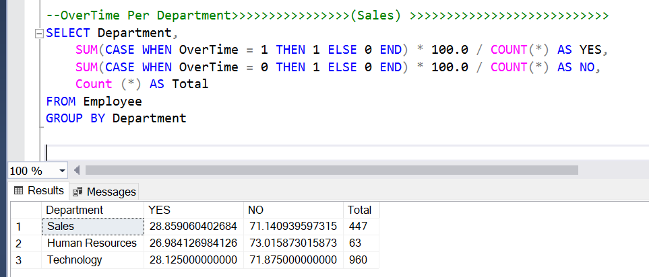

**13- Attrition per Years At company**

**📊 Key Findings:**

1. **Higher Attrition for Newer Employees**
   * Employees with 0 years at the company (new hires) have the highest attrition rate at 31.58%.
   * Attrition remains relatively high in the first few years (e.g., 20.16% at year 1, 16.21% at year 2).
2. Attrition Decreases with More Experience
   * Employees with 10 years at the company have the lowest attrition rate (0.78%), meaning long-term employees are more likely to stay.

✅ **Actionable Recommendations:**

📌 Improve Onboarding & Early Career Engagement

* High attrition among new employees (31.58%) suggests issues with onboarding, role expectations, or job satisfaction.
* Implement stronger mentorship programs, career growth opportunities, and engagement activities for employees in their first 3 years.

📌 Investigate Reasons for Early Departures

* Conduct exit interviews for employees leaving within their first 1–3 years to understand key reasons for departure (e.g., salary, work-life balance, career development).

📌 Leverage Retention Strategies for Mid-Tenure Employees

* Attrition at years 4-6 is still moderate (7%–17%), so offer training, promotions, and flexible work arrangements to keep them engaged.

📌 Recognize and Reward Long-Tenure Employees

* Employees with 10+ years of experience rarely leave. Consider recognition programs and incentives to reward loyalty and prevent burnout.

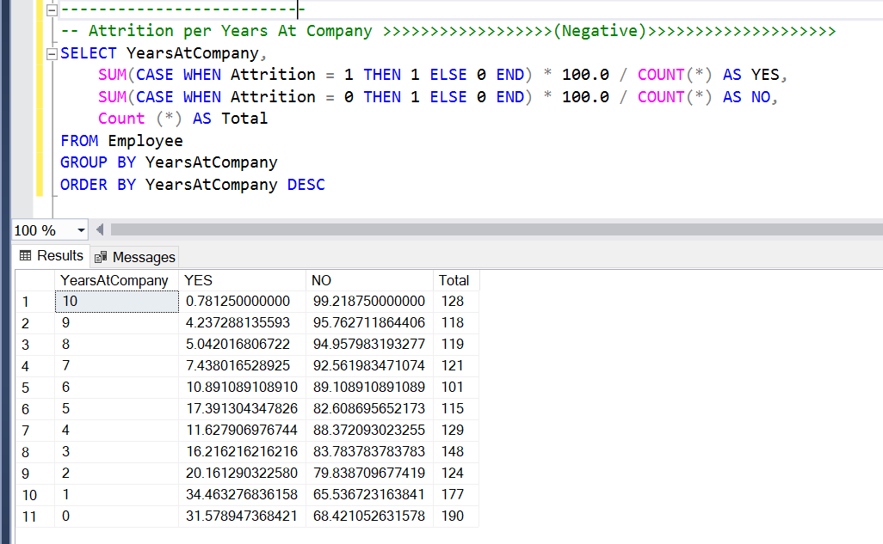

**14- Attrition per Distance range :**

**📊 Key Findings:**

1. **Employees living farthest (Above 40 km) have the highest attrition rate (19.73%)**
   * This suggests that long commuting distances negatively impact employee retention.
   * Possible reasons: travel costs, fatigue, work-life balance issues, or dissatisfaction with remote work policies.
2. **Employees within 30-40 km have the lowest attrition rate (13.99%)**
   * Surprisingly, this group has a lower attrition rate than even the nearest distance ranges.
   * This could indicate better job satisfaction, benefits, or stability among employees in this range.
3. **Short-distance employees (1-10 km) still have a relatively high attrition rate (17.7%)**
   * This might indicate that proximity alone does not ensure employee retention.
   * Possible causes: better job opportunities nearby, dissatisfaction with the job itself, or workplace culture issues.
4. **Employees in the 10-30 km range have moderate attrition rates (15.18% - 16.22%)**
   * This suggests that the ideal commuting range for lower attrition is between 10-40 km, where employees might balance stability with accessibility.

**So, Attrition Rate is Relatively Similar Across Distance Ranges**

* **The attrition rate varies between 15.18% (20-30 km) and 19.73% (Above 40 km).**
* **This suggests that while distance may play a role in attrition, it is not the sole determining factor.**

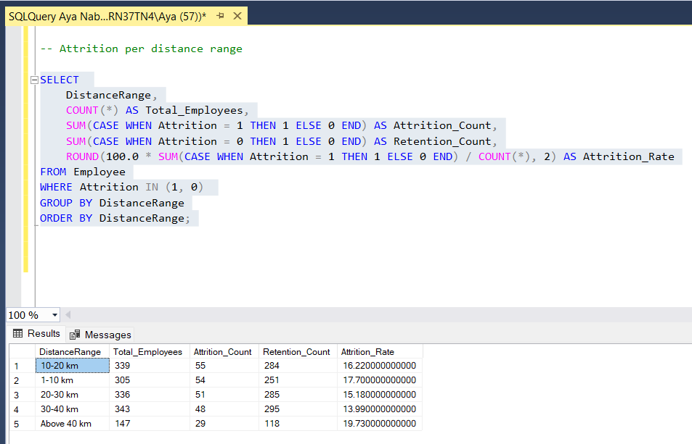

**15- Attrition per Education level**

**📊 Key Findings:**

1. **Doctorate holders have the lowest attrition rate (10.42%)**
   * This could be due to better job roles, higher salaries, or stronger career satisfaction.
2. **Employees with No Formal Qualifications have the highest attrition rate (18.24%)**
   * This suggests that employees without formal education may face career instability, lower salaries, or lack of growth opportunities, leading to higher attrition.

✅ **Actionable Recommendations:**

✔ Retention Strategies:

* Provide career growth programs and upskilling opportunities for employees with lower education levels.
* Implement mentorship programs for Bachelor's and High School graduates to reduce attrition.

✔ Salary & Benefits Analysis:

* Check if salary gaps exist across education levels and if they contribute to attrition.

✔ Work-Life Balance & Job Satisfaction Surveys:

* Understand why Bachelor’s degree holders have a higher attrition rate despite being a majority in the company.

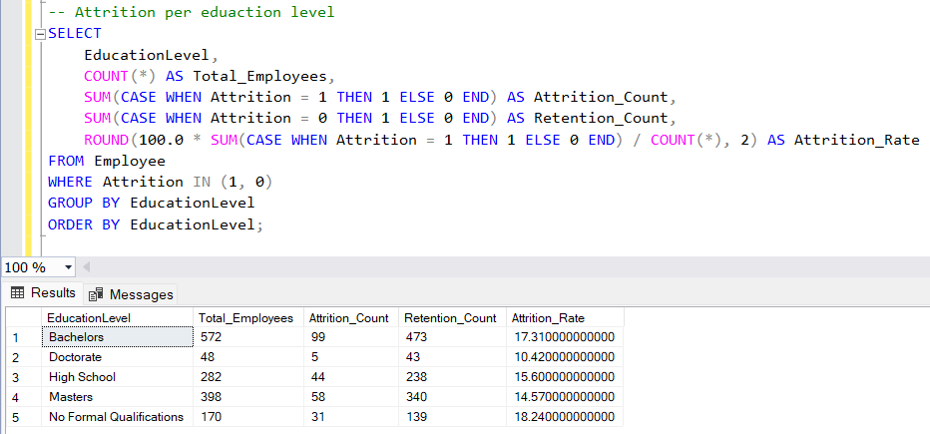

**16- Attrition per Education field**

**📊 Key Findings:**

1. **Highest Attrition Rate: Technical Degree (31.58%)**
   * This suggests that employees with technical skills might have more job opportunities elsewhere or seek better career growth and pay.
   * Action: HR should analyze why technical degree holders are leaving—consider career development programs, better compensation, or skill utilization.
2. **Human Resources (HR) has the second-highest attrition rate (25.93%)**
   * HR professionals might be more aware of job market trends and leave for better opportunities.
   * Action: Improve retention efforts for HR professionals by ensuring competitive salaries, growth opportunities, and engagement programs.
3. **Business Studies (21.28%) and Marketing (20%) also have high attrition**
   * These fields are known for high mobility and competitive job markets.
   * Action: Consider better career paths, leadership training, and job satisfaction surveys to understand what drives attrition.
4. **Lowest Attrition Rate: Information Systems (12.95%) and Computer Science (13.41%)**
   * Despite high demand for IT professionals, attrition is lower.
   * This may indicate job stability, satisfaction, or company-specific benefits for tech employees.
   * Action: Maintain competitive salaries and training programs to retain tech talent.
5. **Economics (15.84%) has a moderate attrition rate**
   * Employees in this field might have stable career paths, leading to slightly lower turnover.
   * Action: Conduct exit interviews to see if attrition reasons differ from other fields.

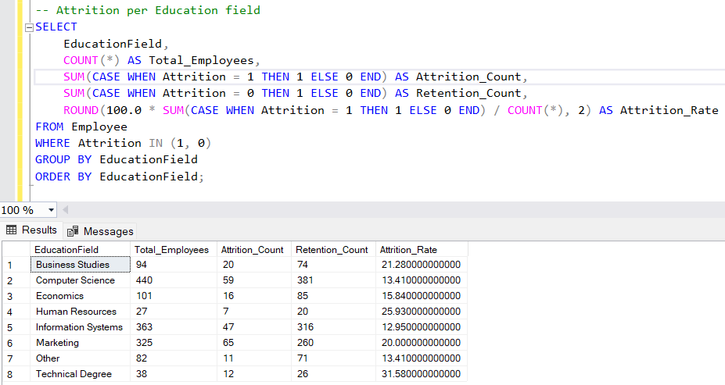

**17- Attrition per Stock option level**

**📊 Key Findings:**

* The highest attrition rate is at **Stock Option Level 0**.
* Employees with **higher stock options (levels 1-3)** have significantly lower attrition.
* This indicates that **offering stock options might be a strong retention factor**.
* Employees who don’t receive stock options may feel undervalued and seek opportunities elsewhere.

✅ **Actionable Recommendations:**

1. **Onboarding & Career Growth**
   * New employees should have clear **career growth paths** to encourage long-term commitment.
   * Regular **check-ins** with new hires and their managers can help address concerns early.
2. **Improve Manager Training**
   * Since attrition is high in the first year with a manager, focus on **leadership development**.
   * Implement **mentorship programs** to build better relationships.
3. **Increase Stock Option Incentives**
   * Employees with stock options stay longer—**expand stock options to more employees**.
   * Use stock options as a **retention tool** to reduce turnover.

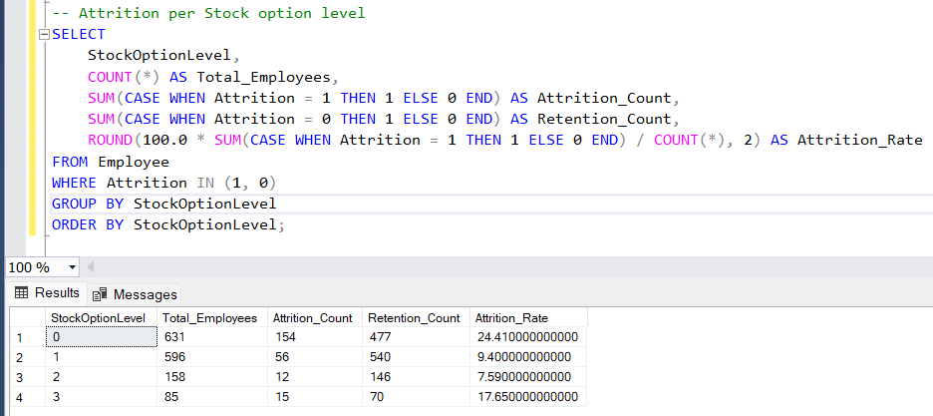

* **Performance Analysis by SQL**

1. **Performance per Education Field**

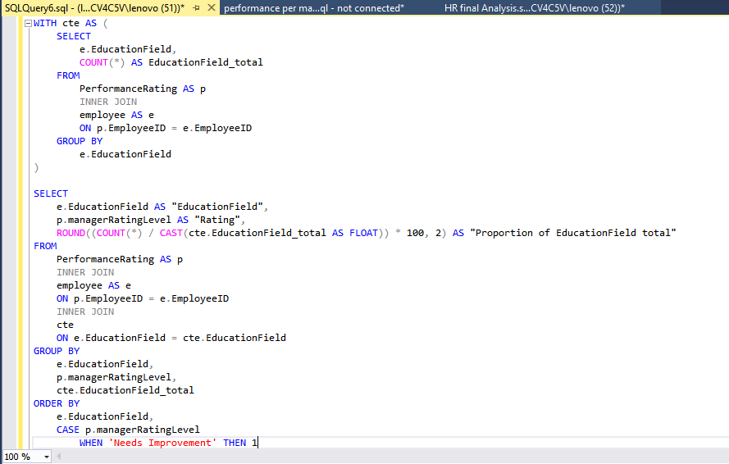

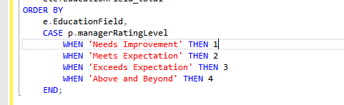

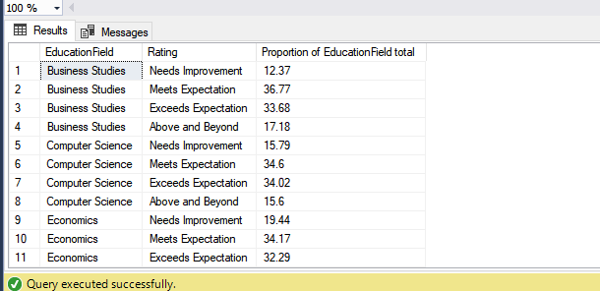

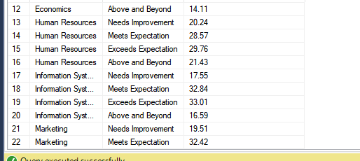

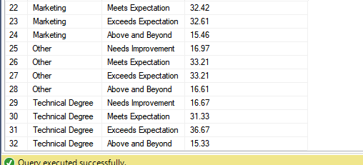

|  |  |  |  |  |  |  |  |
| --- | --- | --- | --- | --- | --- | --- | --- |
| Business | Compu | Econo | HR | Info | Market | Other | Techn |
| Needs Improvement | | | | | | | |
| 12.37 | 15.79 | 19.44 | 20.24 | 17.55 | 19.51 | 16.97 | 16.67 |
| Meets Expectations | | | | | | | |
| 36.77 | 34.6 | 34.17 | 28.57 | 32.84 | 32.42 | 33.21 | 31.33 |
| Exceed Expectations | | | | | | | |
| 33.68 | 34.02 | 32.29 | 29.76 | 33.01 | 32.61 | 33.21 | 36.67 |
| Above and Beyond | | | | | | | |
| 17.18 | 15.6 | 14.11 | 21.43 | 16.59 | 15.46 | 16.61 | 15.33 |

1. **Education field per training opportunities taken ( average training)**

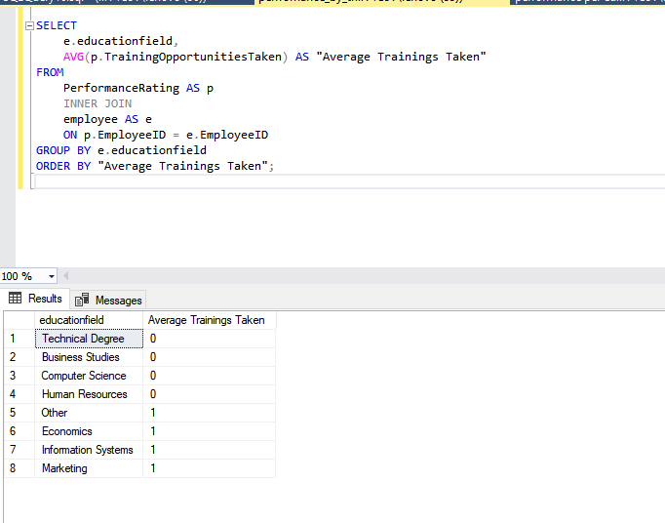

1. **Education field per training opportunities taken ( sum of training)**

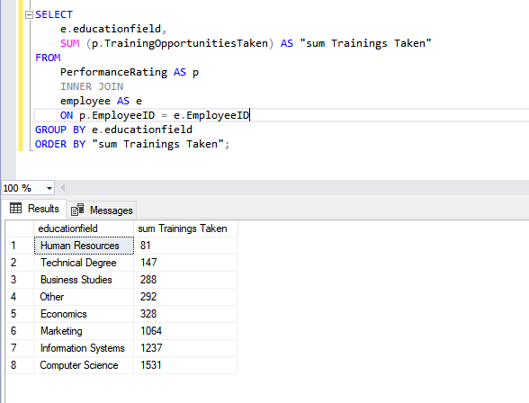

HR education field employees have the highest proportion of needs improvement with lowest proportions of meets expectations and exceed expectations, that may be because HR has the lowest training opportunities taken.

1. **Performance per Education Level**

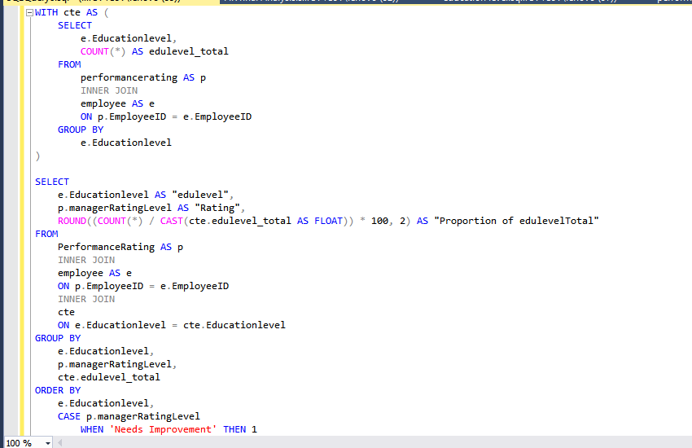 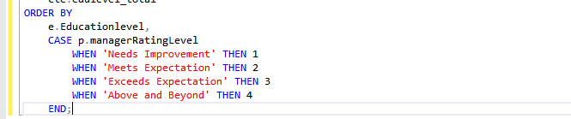

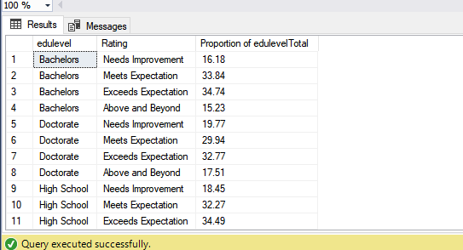

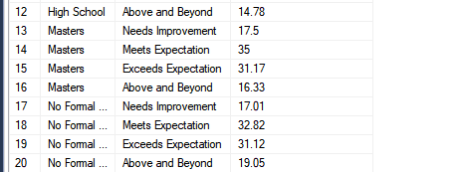

|  |  |  |  |  |
| --- | --- | --- | --- | --- |
| bachelor | doctorate | High school | master | No formal |
| Need improvement | | | | |
| 16.18 | 19.77 | 18.45 | 17.5 | 17.01 |
| Meets expectation | | | | |
| 33.84 | 29.94 | 32.27 | 35 | 32.82 |
| Exceed expectation | | | | |
| 34.74 | 32.77 | 34.49 | 31.17 | 31.12 |
| Above and beyond | | | | |
| 15.23 | 17.51 | 18.78 | 16.33 | 19.05 |

1. **Education level per training opportunities taken ( average training)**

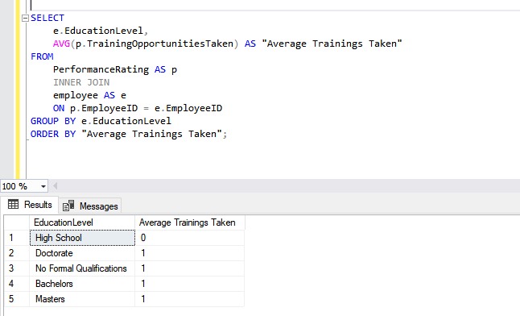

1. **Education level per training opportunities taken ( sum of training)**

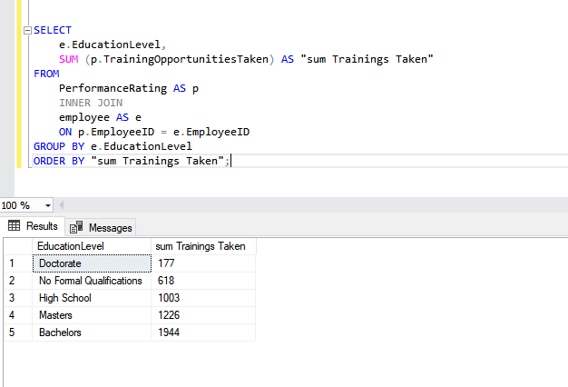

The employees with doctorate who need improvement are the highest proportion but with the bachelor who need improvement are the lowest proportion that might be because the lowest training is for doctorate but the highest for bachelors

1. **Performance per Ethnicity (Proportion)**

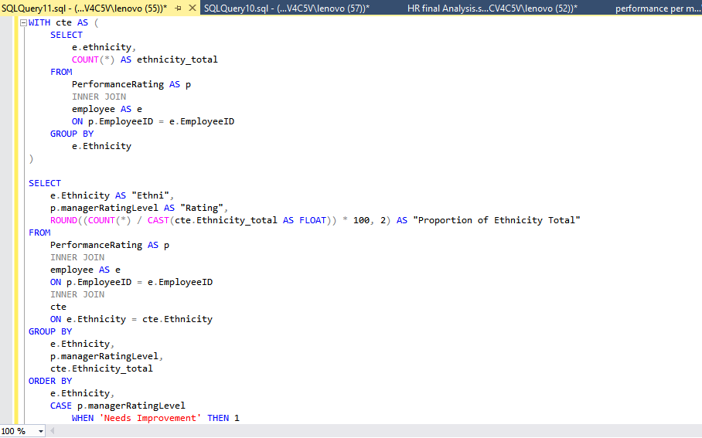

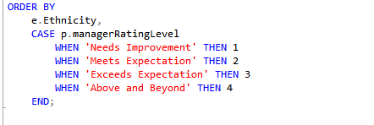

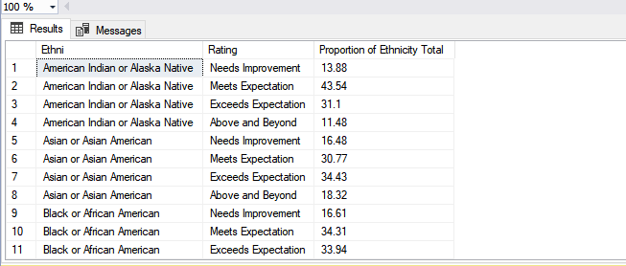

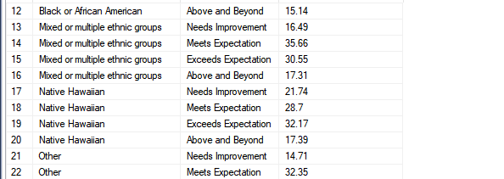

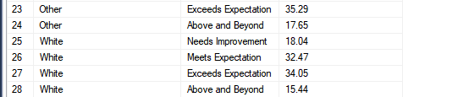

|  |  |  |  |  |  |  |
| --- | --- | --- | --- | --- | --- | --- |
| American Indian | Asian | Black | Mixed | Native Hawaiian | Other | White |
| Needs Improvement | | | | | | |
| 13.88 | 16.48 | 16.61 | 16.49 | 21.74 | 14.71 | 18.04 |
| Meets Expectation | | | | | | |
| 43.54 | 30.77 | 34.31 | 35.66 | 28.7 | 35 | 32.47 |
| Exceed Expectation | | | | | | |
| 31.1 | 34.43 | 33.9 | 30.55 | 32.17 | 35.29 | 34.05 |
| Above and Beyond | | | | | | |
| 11.48 | 18.32 | 15.14 | 17.31 | 17.39 | 17.65 | 15.44 |

The highest proportion of employees who need improvement are Native Hawaiian ( that might be because this category have low number of training opportunities taken) followed by white , the highest who meet expectations are American Indians while Asian are the highest proportion of above and beyond

1. **Training per Ethnicity (average)**

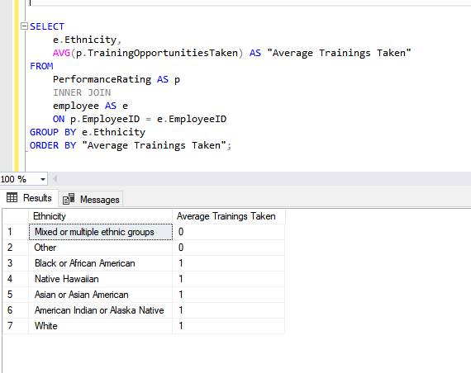

1. **Training per Ethnicity (sum)**

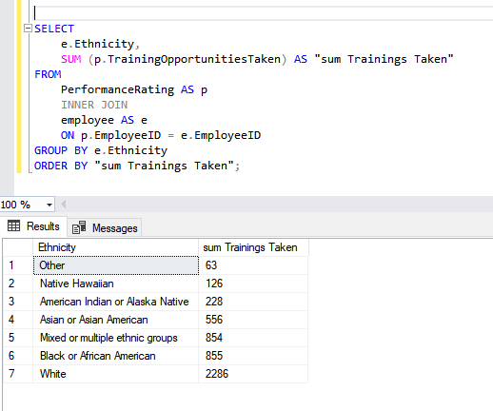

1. **Performance per Stock option level proportion**

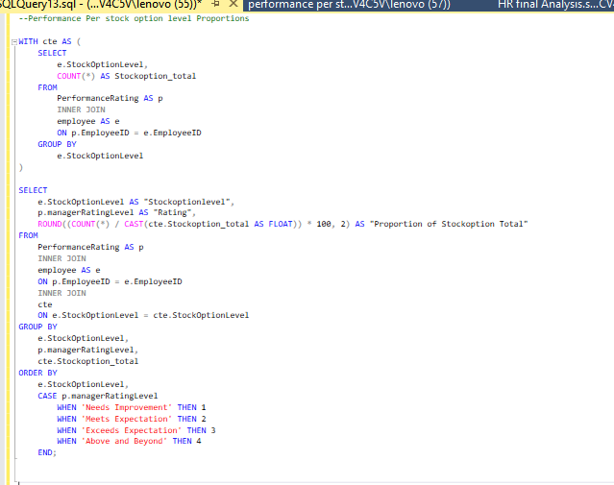

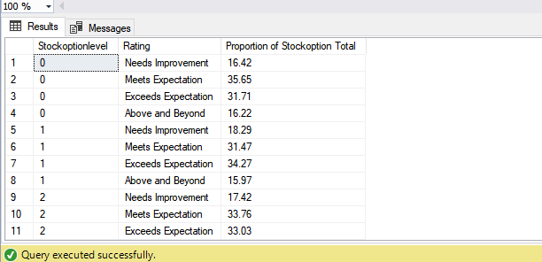

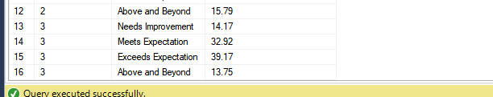

|  |  |  |  |
| --- | --- | --- | --- |
| 0 | 1 | 2 | 3 |
| Needs Improvement | | | |
| 16.42 | 18.29 | 17.42 | 14.17 |
| Meets Expectations | | | |
| 35.65 | 31.47 | 33.76 | 32.92 |
| Exceed Expectations | | | |
| 31.71 | 34.27 | 33.03 | 39.17 |
| Above and beyond | | | |
| 16.22 | 15.97 | 15.79 | 13.75 |

The highest proportion who need improvement and who meet expectations are those who have stock option level 1 ( that might be because the employees of this category have the lowest average of training opportunities taken), on the other side the lowest proportion of needs improvement is for stock option level 3, and the highest proportion who exceed expectations is for stock option level 3.

1. **Training per stock option level**

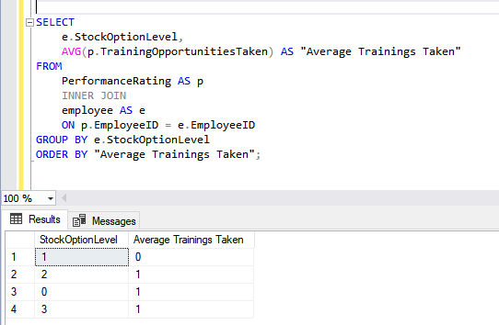

1. **Performance per Years with current manager**

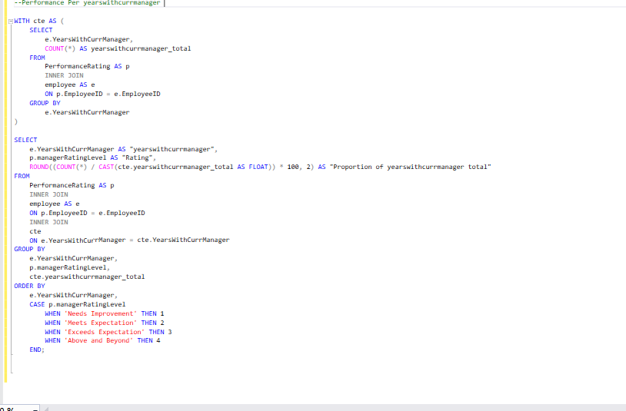

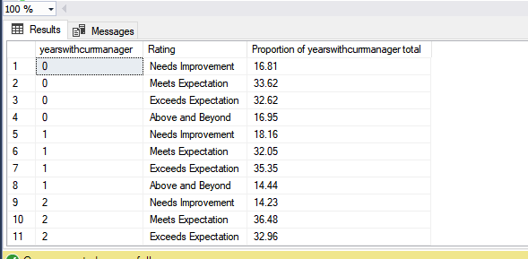

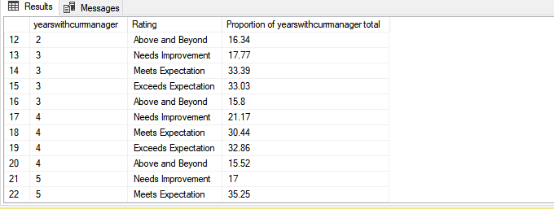

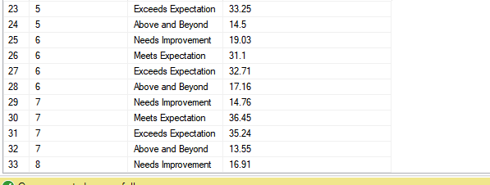

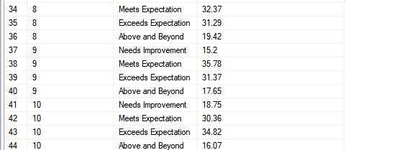

1. **Performance per Job Role**

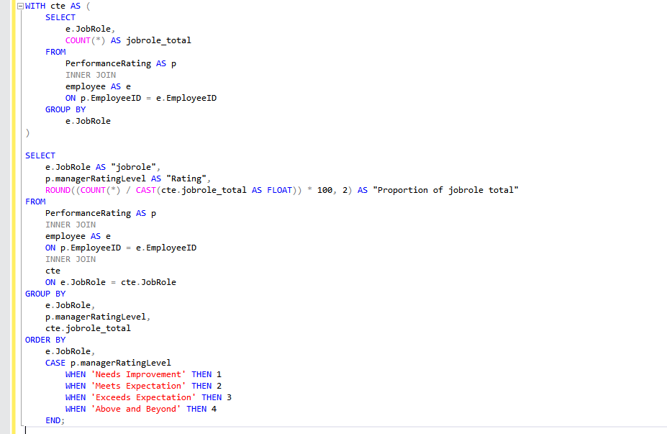

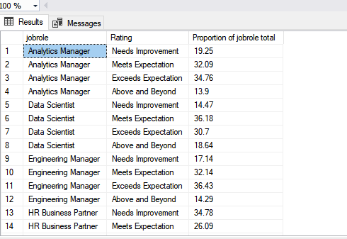

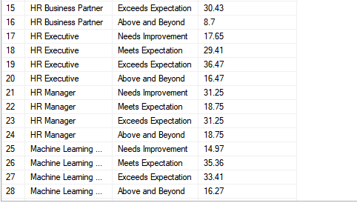

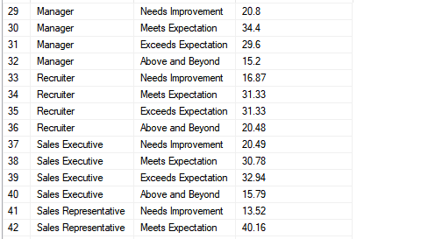

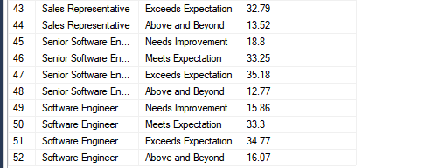

The highest proportion for need improvement is for HR business partner (34.78%) (that might be because the employees of that category have the lowest training opportunities taken) followed by HR manger 31.25%

1. **Training per job role**

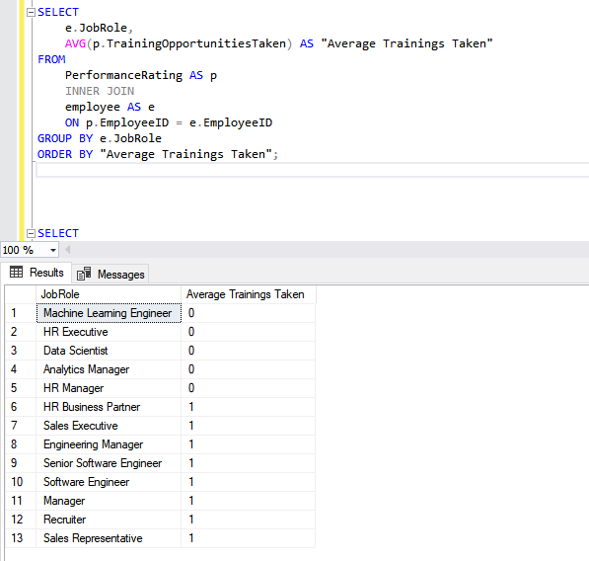



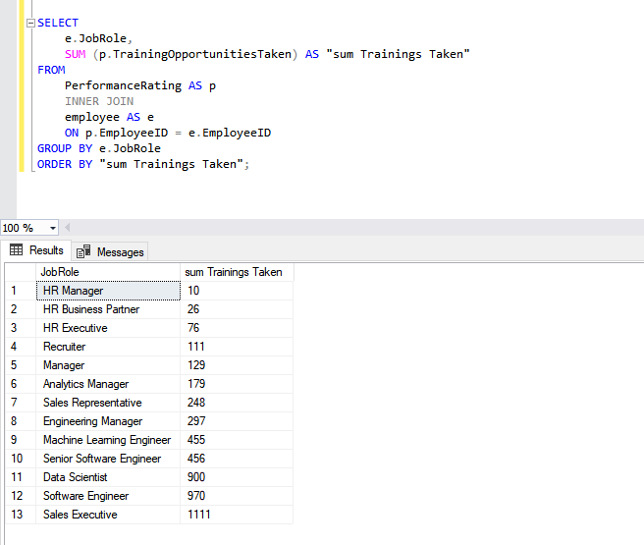

1. **Years in most recent role**

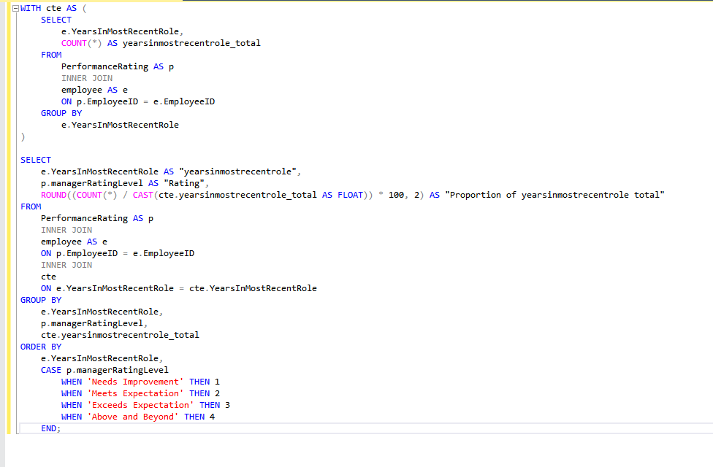

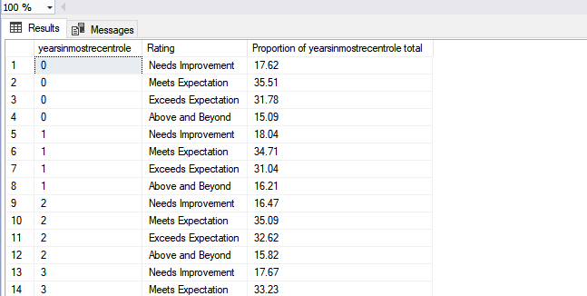

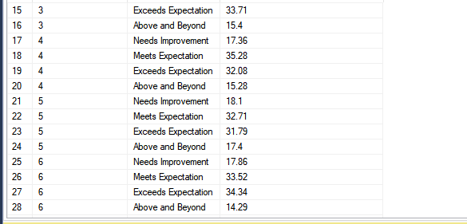

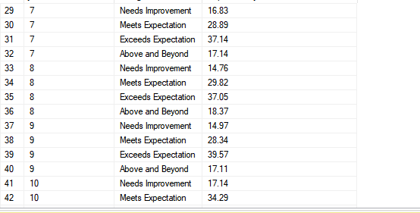



1. **Performance per salary**

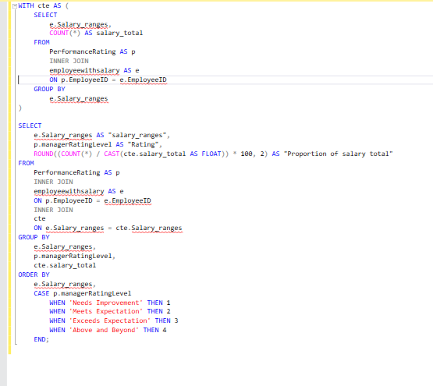

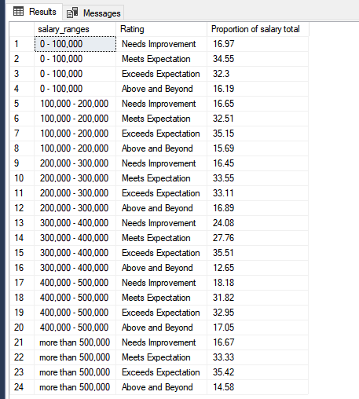

1. **Performance per overtime**

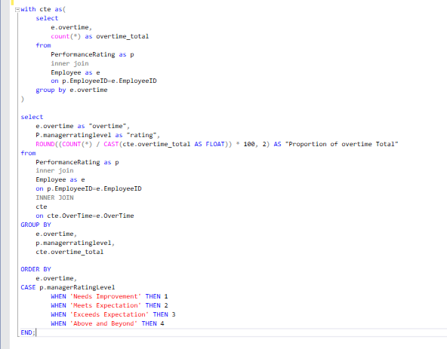

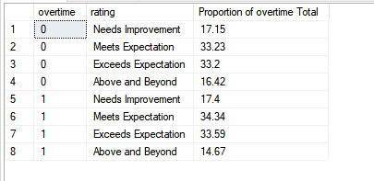

1. **Performance per years at company**

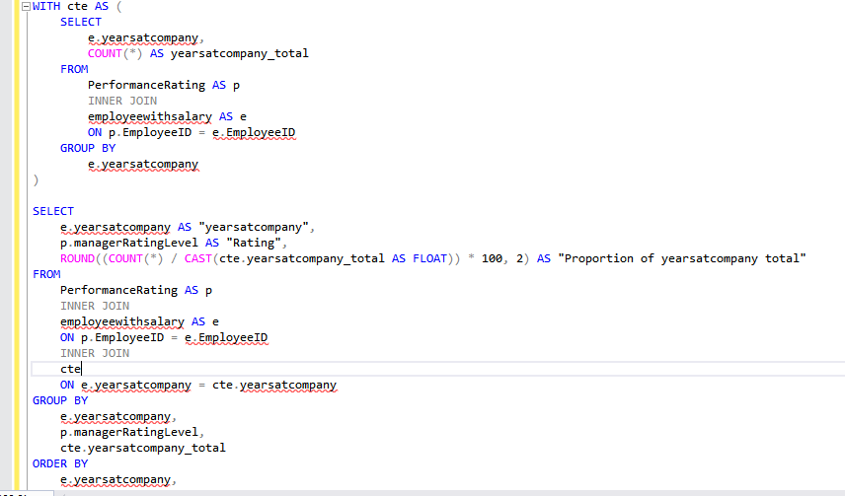

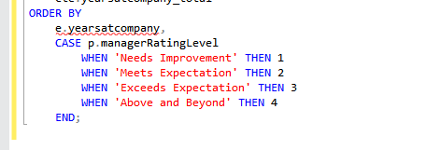

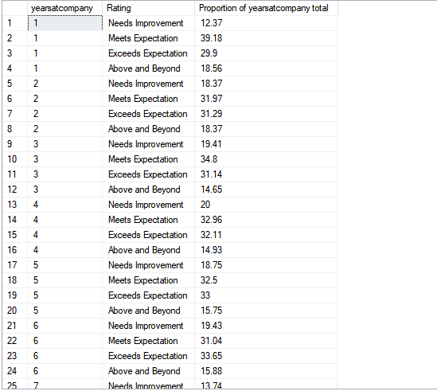

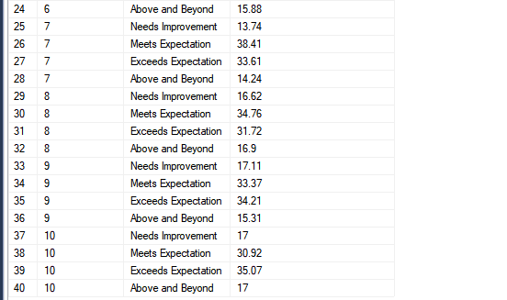

1. **Performance per age**

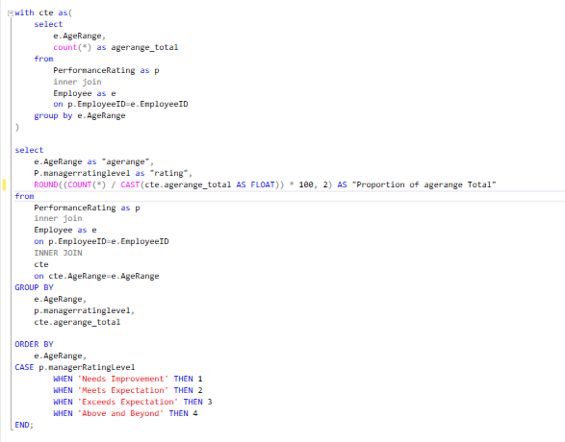

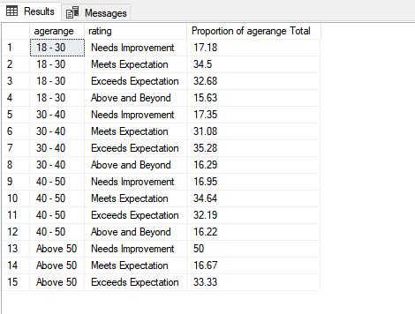

Employees who have age above 50 are of the highest need improvement manger rating level proportion (50%)

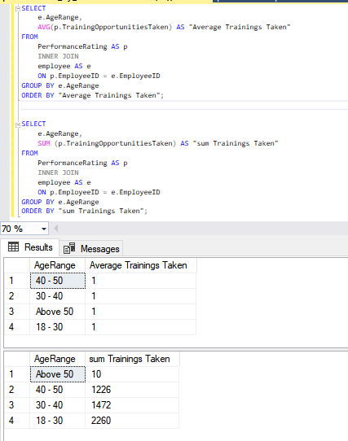

1. **Performance per gender**

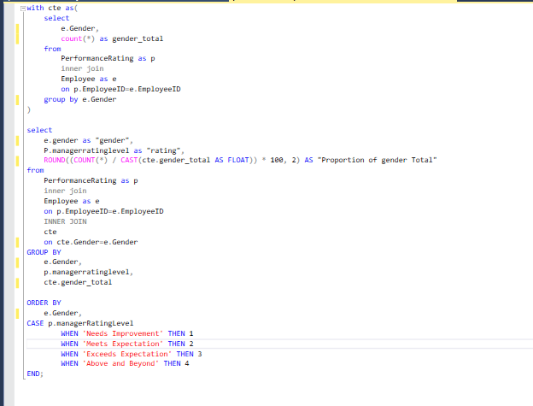

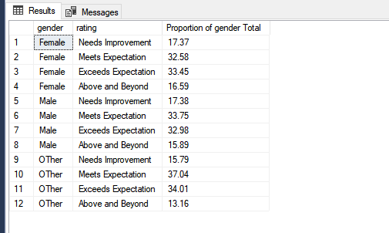

1. **Performance per marital status**

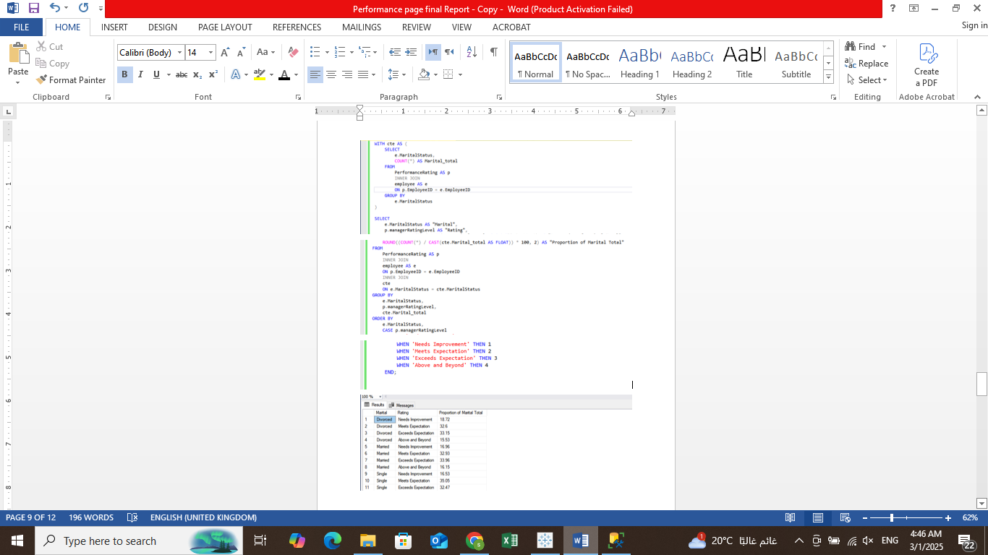

1. **Performance per job satisfaction**

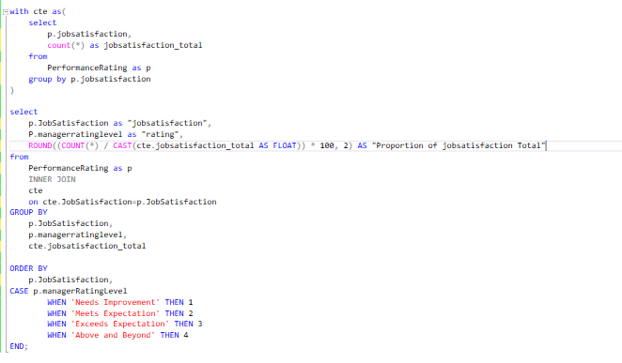

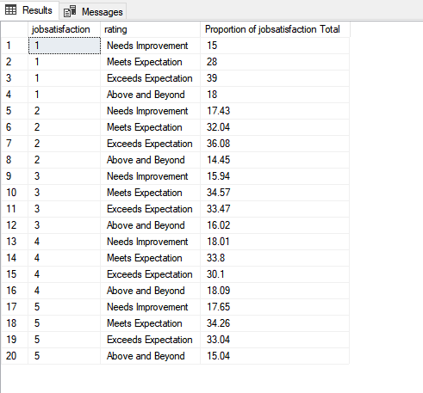

1. Performance per distance from home

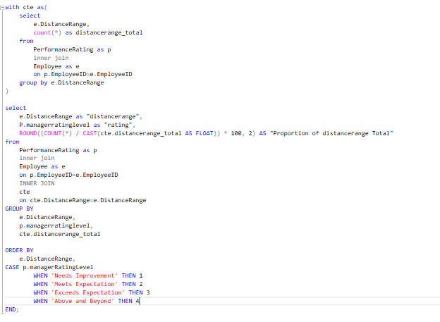

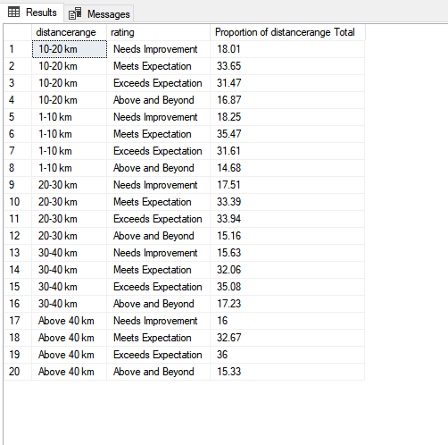

As distance of the work from home increases as the manager rating level worsening

As where the distance range was 1-10 km, the proportion of need improvement rating level was 18.25% , but when the distance increased to 10-20 km the proportion of need improvement rating level decreased to 18.01 , but when increased to above 40 km, the need improvement decreased to 16%.